InfoServer
GPS-Disciplined Stratum-1 Network Time and Information Server
Assembly Manual

October 2026
This manual describes the assembly, bring-up, and testing of the InfoServer from a bare PCB and components — a self-contained network time server that derives time from a GPS receiver (or an upstream Internet time server), disciplines a temperature-compensated DS3231 real-time clock to that source, and serves it to NTP clients on the local network.
Revision/Update Information: | Document Revision 1.6
Hardware Revision: | 6
Companion Firmware Version: | 1.9
Designed by Mitchell Feig
Copyright © 2024–2026 Mitchell Feig

Table of Contents

1. Introduction 1-1
2. Safety Warnings 2-1
3. Required Tools and Equipment 3-1
4. Assembly Sequence 4-1
5. Initial Power-On and Testing 5-1
6. Troubleshooting 6-1
Appendix A — Bill of Materials A-1
Appendix B — Schematic and Wiring Reference B-1

1. Introduction

This manual covers the assembly, bring-up, and testing of the InfoServer from a bare PCB and components. The InfoServer is a stratum-1 network time server built on an ESP32-S3: it derives time from a u-blox GPS receiver (NMEA plus a 1PPS one-pulse-per-second edge), disciplines a temperature-compensated DS3231 real-time clock to that source, and serves the result to NTP clients on the local network. A 74HCT14 level shifter drives a four-LED APA102 string — two status indicators and two under-lights — on the FSPI hardware-SPI bus.
The board is a single mixed-technology assembly. Its functional blocks are:
- Power and USB — 5 V USB-C input and the 3.3 V rail for the ESP32-S3.
- Processor — the ESP32-S3-WROOM-1 module, the SW1 button, and the EN reset button.
- Timekeeping — the DS3231 RTC with its coin-cell backup and I²C pull-ups.
- GPS — the u-blox receiver with its NMEA serial link, 1PPS edge, and reset line.
- LEDs — the 74HCT14 level shifter and the four-LED APA102 string.
Unlike a high-voltage build, the InfoServer runs entirely from 5 V USB-C and a 3.3 V rail — there is no lethal voltage anywhere on the board. The assembly is still fine-pitch surface-mount work, so the order in Section 4 is chosen to make the hardest parts easiest. The GPS module is installed first, while the board is still bare and fully accessible; after that, part order does not matter.
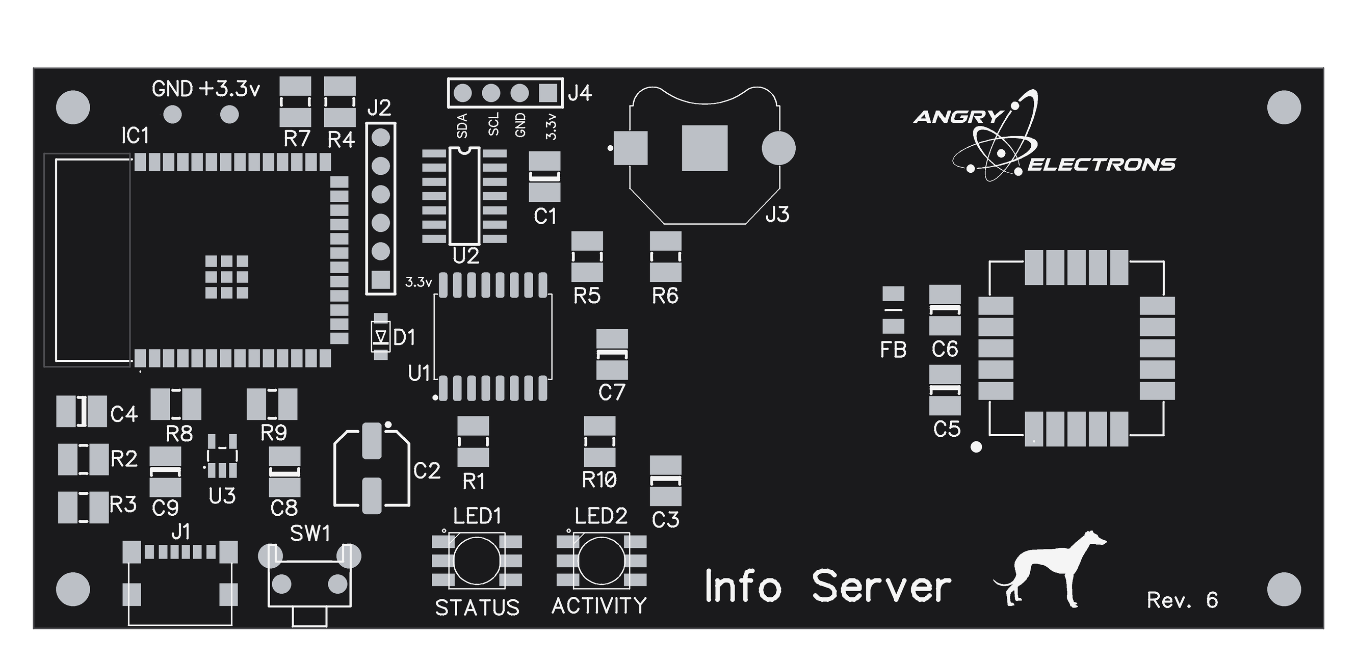
Figure 1 — Top-side component placement (Rev. 6 silkscreen). IC1 is the ESP32-S3 module at the left end; the GPS receiver occupies the right-hand end of the board.

2. Safety Warnings

CAUTION: This board contains static-sensitive devices (the ESP32-S3 module, the GPS receiver, the DS3231, and the 74HCT14). Work at an ESD-safe station and wear a grounded wrist strap before handling any component.
CAUTION: The GPS receiver and the ESP32-S3 module are fine-pitch parts with a polarity/pin-1 marking. Installing either one rotated will damage it on power-up. Confirm the pin-1 dot before applying the iron, and confirm pin alignment again before applying power.
CAUTION: Observe correct polarity on the coin cell and on any electrolytic capacitors. A reversed coin cell can damage the DS3231; a reversed electrolytic can vent or fail.
CAUTION: Power the finished board only from a standard 5 V USB-C source. Do not feed any higher voltage into the USB-C connector or the 5 V rail.
NOTICE: If for any reason the conditions above and the copyright notice at the end of this manual cannot be met, return the kit or assembled unit in original condition within 30 days of purchase for a full refund, less shipping.

3. Required Tools and Equipment

Soldering
- Hot-air rework station or a reflow hotplate — required for the GPS module, whose pads are underneath it and cannot be reached with an iron
- Solder paste (leaded or lead-free, in a syringe or with a stencil for the GPS footprint)
- Temperature-controlled soldering iron with a fine conical or chisel tip (recommended 330–350°C / 625–660°F) for everything else
- Fine solder (0.5–0.8 mm rosin-core, 60/40 or lead-free)
- Liquid or gel flux (essential for the GPS module and the ESP32-S3 module)
- Solder wick and a desoldering pump
- Fine-tip tweezers for SMD components
- Magnifying visor or bench microscope
Test Equipment
- Digital multimeter (continuity and DC volts)
- 5 V USB-C power supply and cable
- Phone or computer with Wi-Fi and a web browser (for first-boot setup)
Hand Tools
- Flush cutters
- Anti-static wrist strap

4. Assembly Sequence

Install the GPS module first, while the board is bare. It is the one part that must be reflowed, and doing it on an empty board means the hot air or hotplate cannot disturb parts that are already down. After the GPS module is in place, the remaining parts may be installed in any order — there is no required sequence for the rest of the board. Use Figure 1 (Section 1) to locate each reference designator, and inspect every joint under magnification as each part is fitted.

4.1 Step 1: GPS Module (install first, reflow only)
The GPS module (the u-blox SAM-M10Q, at the right-hand end of the board, labeled GPS) is a land-grid-array part: its pads are on its underside, around the perimeter of the package. There is no opening in the board beneath it, so none of those pads can be reached with a soldering iron from either side. This module must be reflowed — with solder paste and either hot air or a hotplate. Do not attempt to solder it with an iron.
Paste and place
1. Apply a small, even amount of solder paste to each pad on the footprint. A stencil gives the most consistent result; a fine syringe tip works well too. Even volume matters more than quantity — an overloaded pad bridges to its neighbour, and a dry one leaves an open joint that cannot be seen afterwards.
2. Orient the module so its pin-1 dot lines up with the dot marked on the board. Do not rely on the outline alone — match the dots.
3. Set the module down squarely on the paste and check the alignment on all four sides. Paste holds the part only lightly, so confirm the position now: once the joints are under the package there is nothing to inspect or nudge.
Reflow
1. Follow the profile specified for the solder paste. As a guide, preheat the board to about 150°C, then bring the joint area to the paste's peak — typically around 215°C for leaded paste or 245°C for lead-free — and hold only long enough for the paste to wet out.
2. Heat the area broadly and evenly rather than blasting one edge. With hot air, keep the nozzle moving and well back from the module so it does not lift.
3. Watch for the moment the paste turns to solder: the module will settle slightly and, if the paste volumes are even, surface tension pulls it square. That settle is the sign the joints have formed.
4. Let the board cool undisturbed. Moving the module while the solder is still plastic is what causes the cold joints that cannot be seen.
Verify
Because the joints are hidden, inspect indirectly. Look around the edge of the package for solder that has squeezed out between pads, which indicates a bridge. Confirm the module has not shifted off its outline. Then check continuity from the module's supply and ground to the corresponding nets, and — once the board is running — confirm the receiver is talking and can reach a fix, which exercises the power, serial, and 1PPS connections together.
CAUTION: Verify the pin-1 dot alignment before applying heat. A module reflowed rotated must be removed with hot air, and reworking an LGA package on a populated board risks the parts around it. Do not try to fix a suspected joint with an iron — the pads are not accessible, and the only correct repair is to reflow the module again.

4.2 Step 2: Microcontroller (IC1, ESP32-S3 module)
Install the ESP32-S3-WROOM-1 module (IC1, at the left-hand end of the board). Unlike the GPS module, its pads are castellations along the two long edges and are fully accessible from the top, so this one is soldered with an iron.
1. Orient the module so its pin-1 / keep-out marking matches the silkscreen on the board.
2. Solder a single pin in place to tack the module down.
3. Carefully check that all pins line up with their pads. If anything is off, re-melt the one tacked joint and correct the position before continuing.
4. Once alignment is confirmed, solder the remaining pins.

4.3 Remaining Components (any order)
With the GPS module and IC1 in place, install the rest of the board in whatever order is convenient. Each small IC has its own pin-1 / keep-out mark — verify it against the silkscreen before soldering, the same as for IC1. Observe the orientation notes below for the keyed and polarized parts.
Small ICs and diode (U1, U2, U3, D1)
1. U1 — DS3231S RTC (SOIC-16). Verify the pin-1 mark against the silkscreen.
2. U2 — 74HCT14 level shifter (SOIC-14). Verify the pin-1 mark.
3. U3 — AP2112K-3.3 V LDO regulator (SOT-23-5), at the lower left beside the USB-C connector.
4. D1 — CDBM-140G Schottky diode. Observe the cathode band against the silkscreen.
Status LEDs and under-lights (LED1–LED4)
1. LED1 (STATUS) and LED2 (ACTIVITY) — the two APA102 indicators on the top of the board, along the lower edge below U1; both are labelled on the silkscreen.
2. LED3 and LED4 — the two APA102 under-lights on the bottom of the board (see Figure 2). Each has a pin-1 dot on its corner.
CAUTION: The four APA102 LEDs are one directional chain (LED1→LED2→LED3→LED4). Install every LED with its data-in and clock-in toward the previous device, matching the pin-1 dot to the silkscreen. One reversed LED breaks the chain past that point.
Passives, buttons, connectors
1. Resistors R1–R10 and capacitors C1–C9 — including the I²C pull-ups (R8, R9), the DS3231 ~RST pull-up (R1), and the GPS RESET_N pull-up (R10).
2. FB — the ferrite bead feeding the GPS supply. It is not polarized, but do not substitute a 0 Ω link: it is there to keep switching noise off the receiver.
3. SW1 — the function button. It is the only switch on the board; there is no separate reset button, and EN and IO0 are brought out on J2 instead.
4. J2 (serial / programming header) and the coin-cell holder (J3) — observe coin-cell polarity, + side up.
5. J4 — the 4-pin environmental sensor header, if a sensor is being fitted. The silkscreen labels each pin (SDA, SCL, GND, 3.3v); match them to the sensor module rather than assuming a pin order. A BME280 or a BME688 may be mounted directly here, or sited away from the board on a short ribbon cable — the firmware identifies which part is fitted at power-on, so no setting has to be changed to match.
6. J1 — the USB-C connector. Seat it flat and fully before soldering the shield tabs.
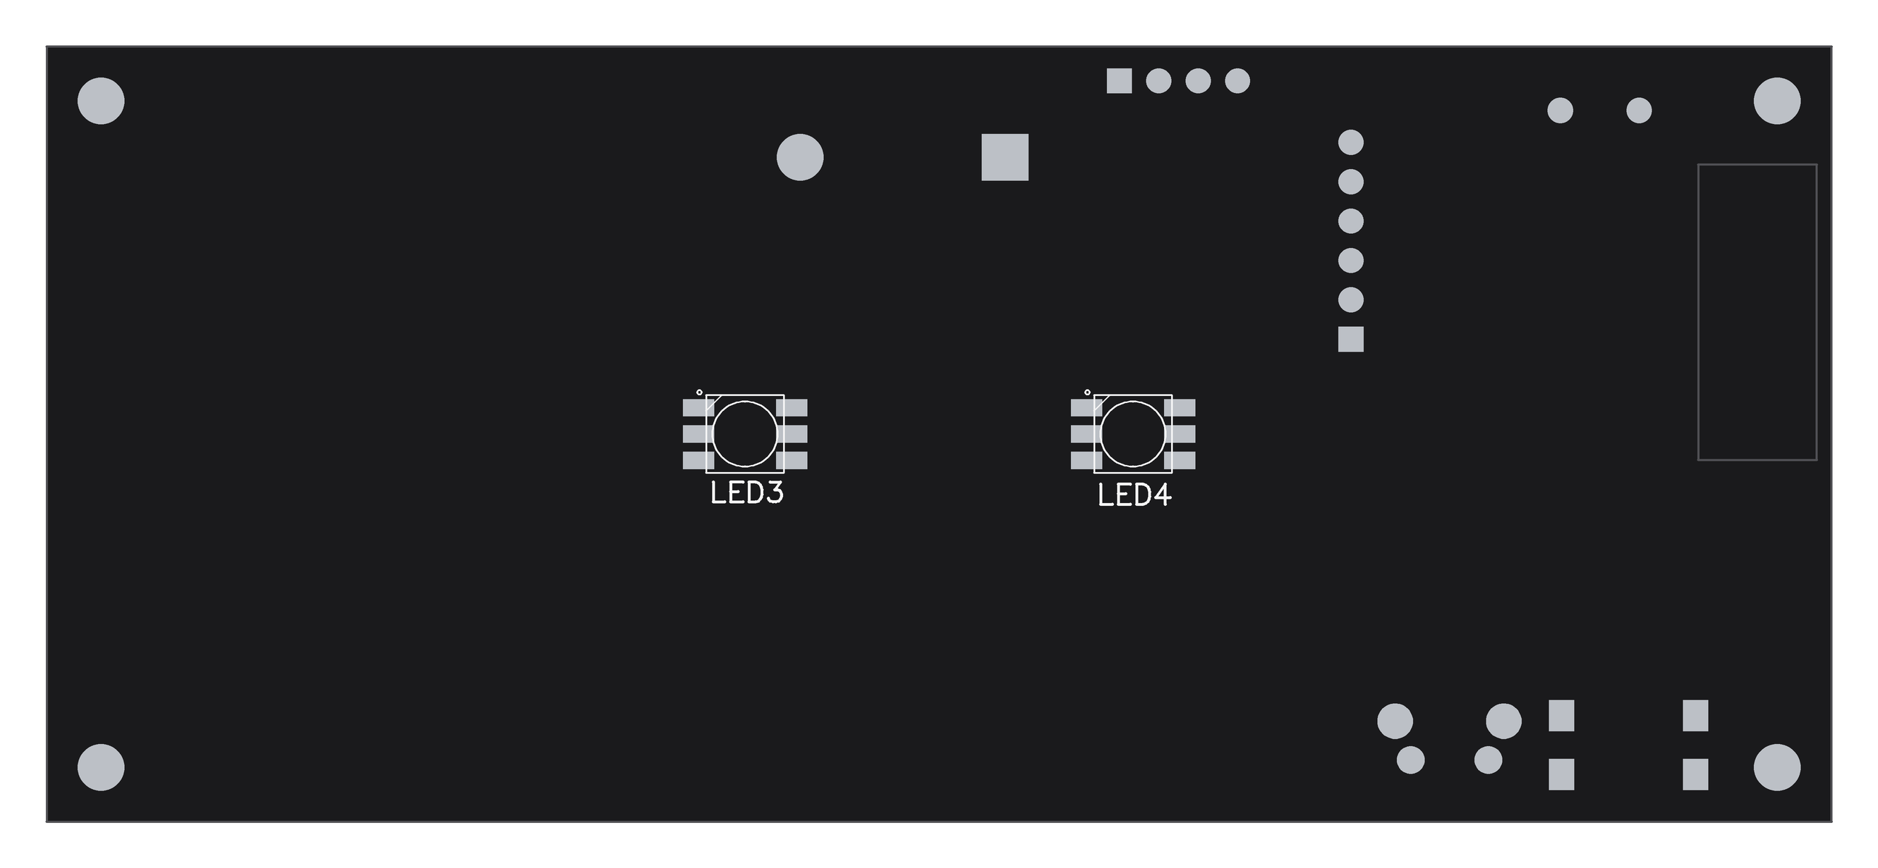
Figure 2 — Bottom-side component placement (mirrored, as seen looking at the underside). LED3 and LED4 are the under-lights.

5. Initial Power-On and Testing

Pre-Power Checks
Before applying power for the first time:
- Visually inspect every joint under magnification, especially the GPS module, the ESP32-S3 module, the DS3231, and the 74HCT14.
- Check for solder bridges on all fine-pitch packages.
- Confirm the coin cell and any electrolytic capacitors are installed with correct polarity.
- Confirm there is no short between 5 V and GND, or between 3.3 V and GND, with a continuity / resistance check.
Power-On Sequence
1. Connect a 5 V USB-C supply. Current draw should be modest with no fault.
2. Verify the 3.3 V rail reads 3.3 V ± 0.1 V.
3. On a brand-new unit the ESP32-S3 creates a Wi-Fi access point named "InfoServer" (no password).
4. From a phone or PC, join that network and browse to 192.168.4.1. At a minimum, select the home network and enter its password, choose the discipline mode (leave it on NMEA GPS), then Save and Start. The unit reboots onto the home network.
5. Give the unit a clear view of the sky. A first GPS fix from a cold start can take from under a minute to several minutes.
Testing Subsystems
LEDs: the STATUS indicator pulses one short heartbeat per second, its color reporting the active source (green on GPS lock, blue on NTP lock, amber in GPS holdover); the ACTIVITY indicator flashes in that same color as NTP time requests are served, and purple as /info requests are served. In AP setup mode both LEDs alternate red. If no LED lights, check the 74HCT14, the LED series resistors, and the data/clock continuity along the chain.
Button: double-click SW1 — the unit should blink out its IP address on the LEDs, one octet at a time. Hold SW1 for ten seconds to trigger an over-the-air update check.
Time source: open the status page (the unit’s IP address, or http://infoserver.local/) and confirm Source shows GPS once a fix is acquired, and that Status reads LOCKED. The GPS−NTP figure should settle to a few milliseconds.

6. Troubleshooting

Symptom | Check | Solution
No power (nothing responds) | USB-C connector, 5 V and 3.3 V rails | Reflow the USB-C shield and power pins. Verify 5 V at the connector and 3.3 V at the regulator output.
ESP32-S3 not booting / no AP | Module solder joints, strapping pins | Reflow the module pins and check for bridges. Re-flash over USB-C if needed. Keep metal away from the module antenna.
Never gets a GPS fix | GPS module orientation, sky view, NMEA link | Confirm the pin-1 dot alignment and that all pins are soldered. Give the unit a clear view of the sky; cold starts under cover can take a long time. Source will read NTP while GPS is unacquired.
Status stuck at NO SYNC | Wi-Fi connection, discipline source | Confirm Wi-Fi is connected so the NTP fallback can work, and that the GPS or NTP source can lock. The server stays silent until it locks.
GPS−NTP shown in red | GPS reception, upstream NTP server | A persistent disagreement over one second. Suspect poor GPS reception or a bad upstream server; try the alternate NTP server.
LEDs do not light | 74HCT14, series resistors, chain continuity | Verify 5 V at the 74HCT14, check the LED series resistors, and confirm data/clock continuity from the level shifter into the first LED.
LED chain partially works | Failed or reversed LED in the chain | Data cascades — a dead or reversed LED breaks the chain past it. Replace or re-orient the first non-working LED.
RTC loses time across power loss | Coin cell, cell polarity, holder | Verify the cell voltage and that it is installed + side up. Reflow the holder contacts.
Buttons do nothing | SW1 / EN solder joints | Reflow the button pins and check continuity to the respective GPIO and GND.

Appendix A — Bill of Materials

Reference designators, parts, and values are taken from the Rev. 6 schematic (Figure 3) and board silkscreen (Figures 1 and 2). Quantities are for one unit.
Modules
Ref | Part | Package | Qty | Description
IC1 | ESP32-S3-WROOM-1-N16R8 | Module | 1 | Wi-Fi microcontroller; 16 MB flash, 8 MB PSRAM
ANT1 | u-blox SAM-M10Q-00B | Module (LGA) | 1 | GPS receiver with integrated antenna; NMEA + 1PPS (silkscreen label: GPS)

Integrated Circuits, Diode, and Ferrite
Ref | Part | Package | Qty | Description
U1 | DS3231S | SOIC-16 | 1 | TCXO real-time clock (±2 ppm), battery-backed
U2 | 74HCT14 | SOIC-14 | 1 | Hex inverting Schmitt trigger — 3.3 V→5 V level shifter for the APA102 string
U3 | AP2112K-3.3 | SOT-23-5 | 1 | 3.3 V LDO regulator
D1 | CDBM-140G | SOD-123F | 1 | Schottky input-protection diode
FB | Würth 74279218 | 0805 | 1 | Ferrite bead — isolates the GPS receiver supply from the 3.3 V rail

LEDs
Ref | Part | Qty | Description
LED1, LED2 | APA102 RGB LED | 2 | Status indicators (top): STATUS, ACTIVITY
LED3, LED4 | APA102 RGB LED | 2 | Under-lights (bottom), constant color

Resistors
Ref | Value | Qty | Description
R1 | 10k | 1 | DS3231 ~RST pull-up (not driven by the MCU)
R4 | 10k | 1 | ESP32-S3 EN (reset) pull-up
R7 | 10k | 1 | ESP32-S3 IO0 (boot mode) pull-up
R10 | 10k | 1 | GPS RESET_N pull-up to the GPS supply
R2, R3 | 5.1k | 2 | USB-C CC1 / CC2 configuration resistors
R5, R6 | 150Ω | 2 | APA102 data / clock series resistors
R8, R9 | 4.7k | 2 | I²C pull-ups (SDA, SCL)

Capacitors
Ref | Value | Qty | Description
C1, C3, C4, C5, C7 | 100 nF | 5 | Supply decoupling (ceramic)
C2 | 100 µF | 1 | Bulk capacitor on the 5 V input (electrolytic)
C6 | 10 µF | 1 | Bulk capacitor on the GPS supply, after FB (electrolytic)
C8, C9 | 1 µF | 2 | LDO input and output capacitors (U3)

Connectors, Switches, and Power
Ref | Part | Qty | Description
J1 | USB4125-GF-A-019 (USB-C) | 1 | 5 V power input
J2 | HDR-1x6 (6-pin header) | 1 | Serial / programming header
J3 | Keystone 3001 holder + CR2032 | 1 | DS3231 backup battery
J4 | HDR-1x4 (4-pin header) | 1 | Environmental sensor — BME280 or BME688, I²C (silkscreen: SDA, SCL, GND, 3.3v). Omit if no sensor is fitted
SW1 | Tactile pushbutton | 1 | Function button — IP readout (double-click), AP mode (5 s hold), OTA update (10 s hold)

Appendix B — Schematic and Wiring Reference

The InfoServer is documented on a single schematic sheet in the DipTrace project (InfoServer2.dch), reproduced as Figure 3 at the end of this appendix. The signal connections below are fixed in the firmware pin map and are the authoritative reference for bring-up and debugging.
ESP32-S3 Pin Map
Function | Signal | ESP32-S3 GPIO | Notes
DS3231 I²C data | SDA | GPIO8 | 4.7k pull-up to 3.3 V
DS3231 I²C clock | SCL | GPIO9 | 4.7k pull-up to 3.3 V
DS3231 1 Hz square wave | SQW | GPIO7 | Open-drain; internal INPUT_PULLUP
DS3231 reset | ~RST | — (none) | Pulled up by R1; its own net, not connected to the MCU
GPS NMEA in (ESP RX ← GPS TXD) | GPS_TX | GPIO15 | Serial2 RX
GPS config out (ESP TX → GPS RXD) | GPS_RX | GPIO16 | Serial2 TX
GPS one-pulse-per-second | PPS | GPIO4 | Timing-critical interrupt edge
GPS reset | RESET_N | GPIO6 | Active LOW; idle INPUT_PULLUP, plus the R10 pull-up to the GPS supply
SW1 button | SW1 | GPIO5 | To GND, internal pull-up, active LOW
APA102 data | LED_DAT | GPIO11 | FSPI MOSI, via 74HCT14 (x2 gates)
APA102 clock | LED_CLK | GPIO12 | FSPI SCK, via 74HCT14 (x2 gates)
BME sensor (optional) | SDA / SCL | GPIO8 / GPIO9 | BME280 or BME688 — shares the DS3231 I²C bus; broken out on J4
SEN66 sensor (optional) | SDA / SCL | GPIO8 / GPIO9 | Same I²C bus, address 0x6B, on a short ribbon cable. Its presence drops the bus to 100 kHz (the SEN66 ceiling); without it the bus runs at 400 kHz
Reset / boot | EN / IO0 | J2 pins 4, 5 | Pulled up by R4 and R7; no on-board button
Power | 5 V | USB-C | 3.3 V rail derived on-board by U3

GPS baud is 9600 (the SAM-M10Q ships at 9600). The APA102 string runs on the FSPI hardware-SPI peripheral, so it has no interaction with NTP packet timing.
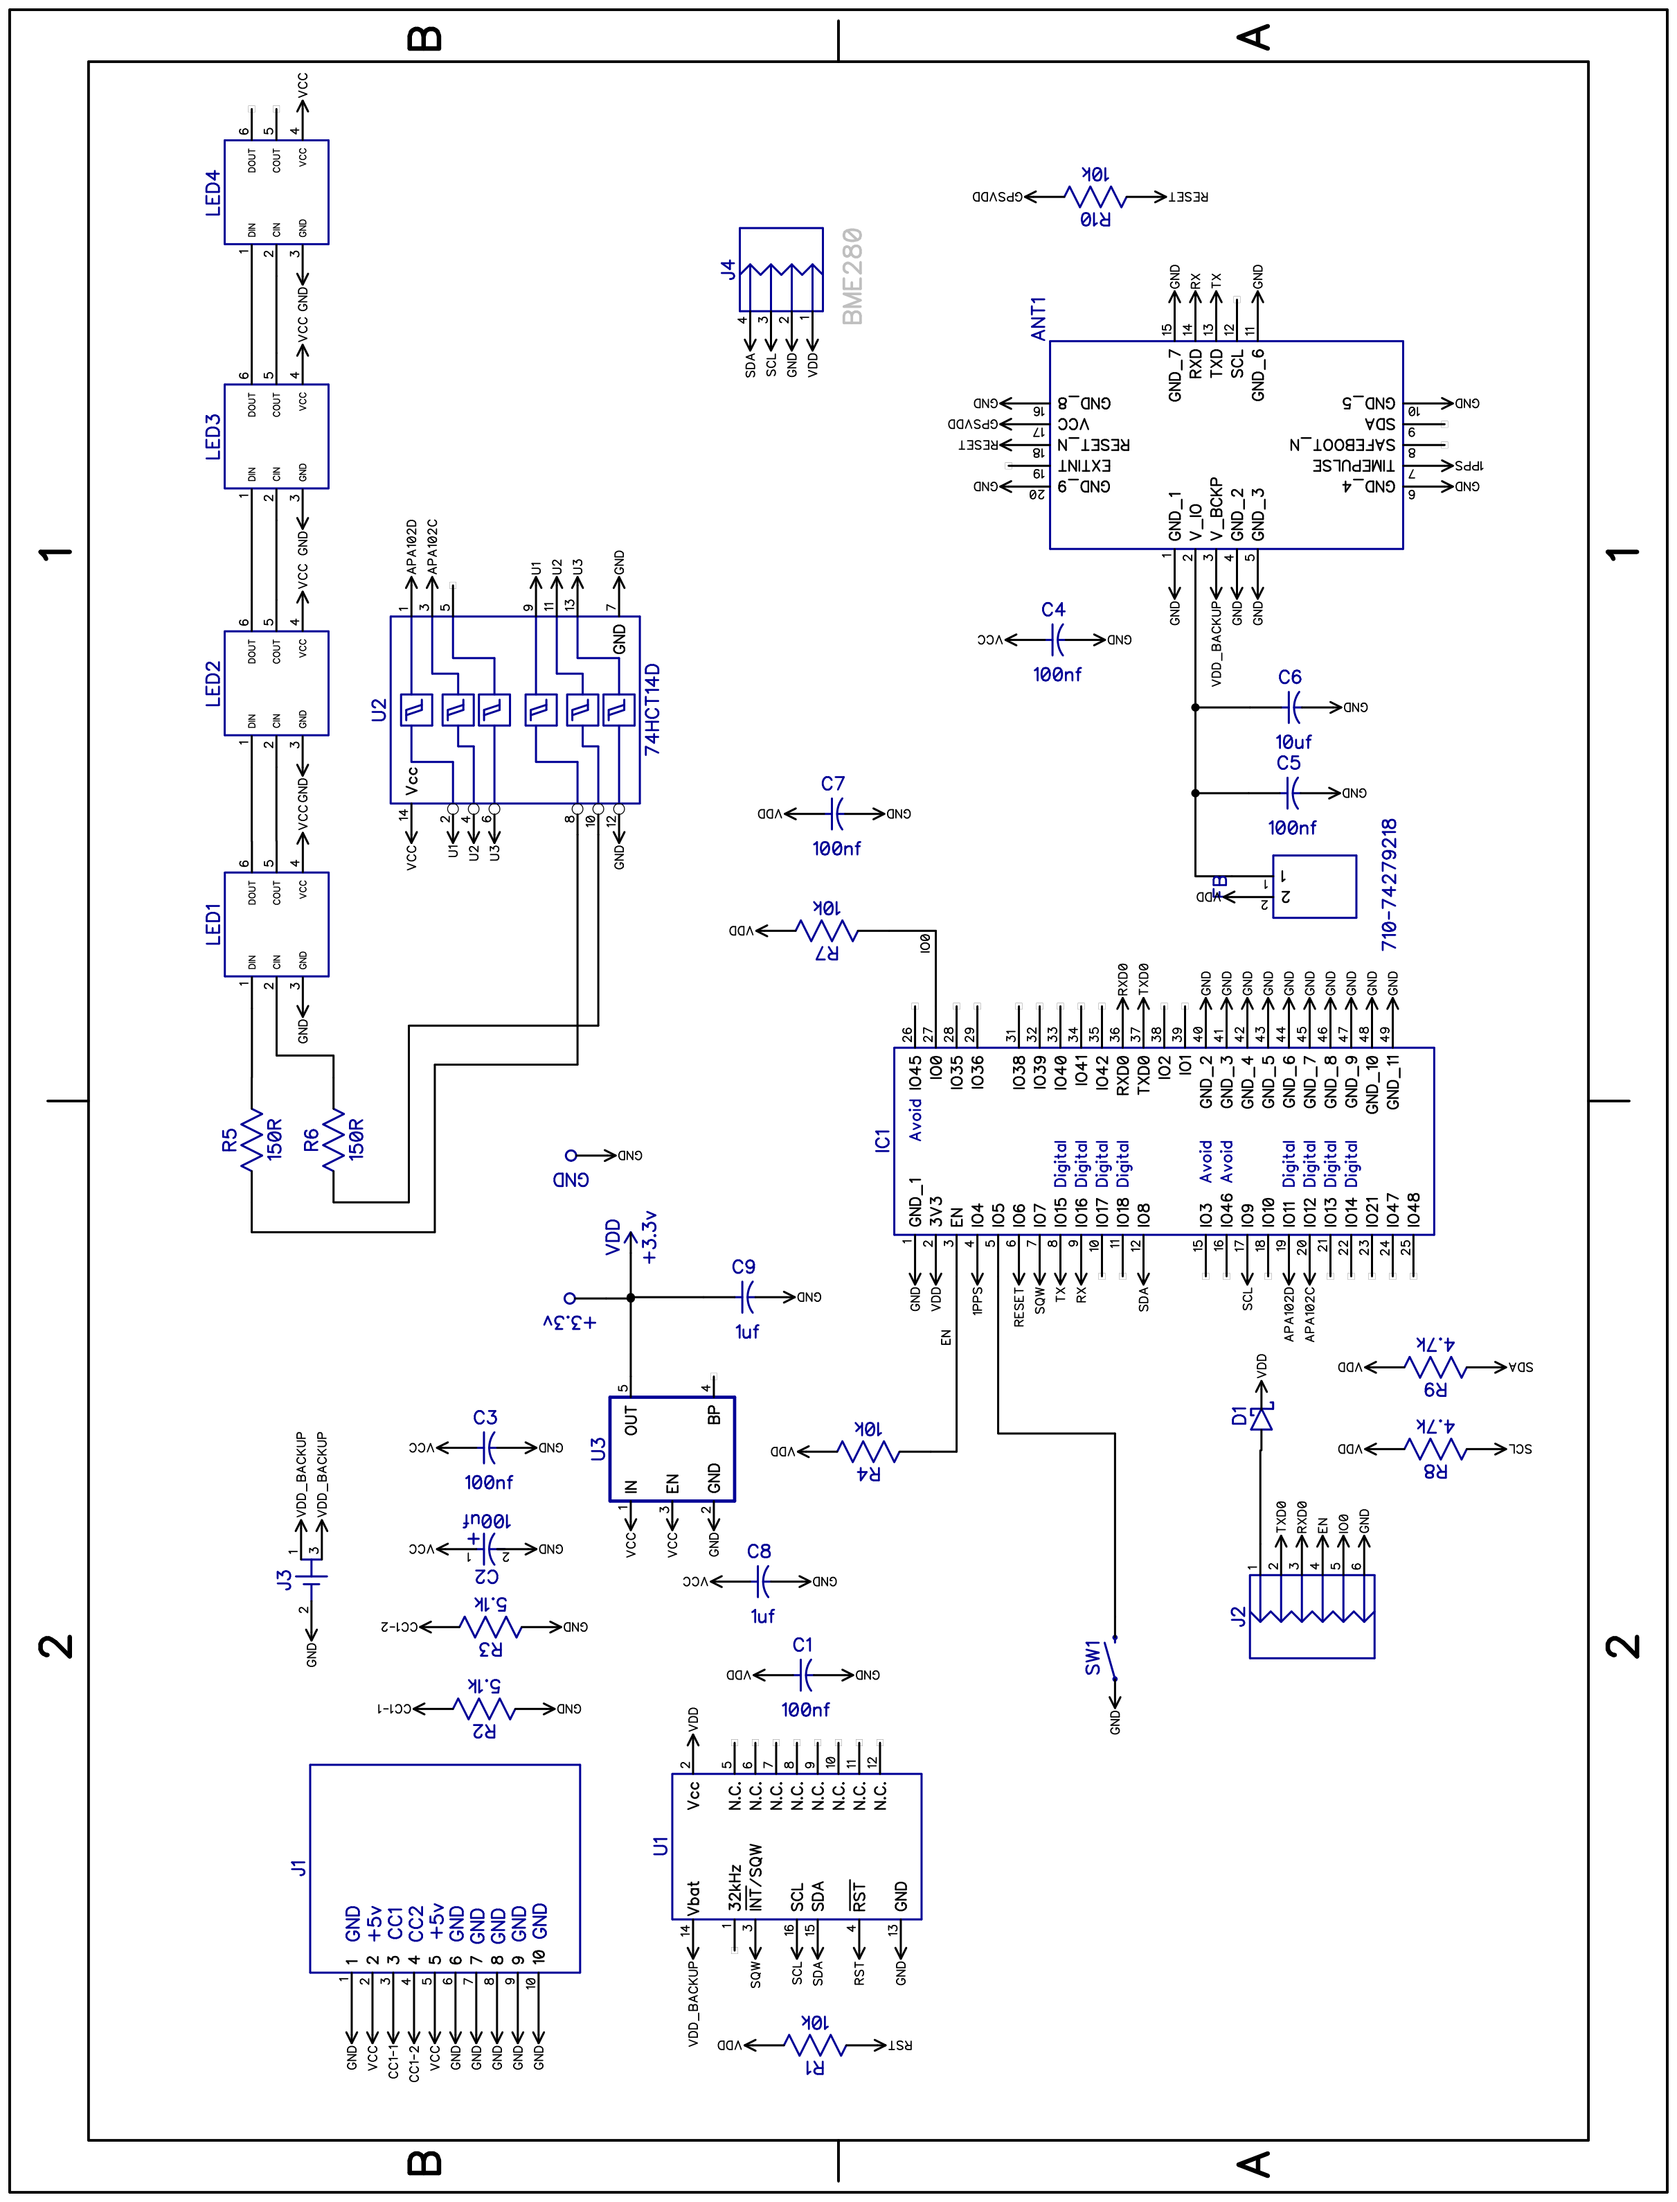
Figure 3 — InfoServer Rev. 6 schematic (single sheet), rotated a quarter turn to print as large as the page allows. The pin map on the preceding page is the quicker lookup for an individual signal.

Copyright and Disclaimer

InfoServer hardware design and documentation © 2024–2026 Mitchell Feig d/b/a Angry Electrons. All rights reserved.
THIS PRODUCT IS PROVIDED "AS IS", WITHOUT WARRANTY OF ANY KIND, EXPRESS OR IMPLIED, INCLUDING BUT NOT LIMITED TO THE WARRANTIES OF MERCHANTABILITY, FITNESS FOR A PARTICULAR PURPOSE, AND NONINFRINGEMENT. IN NO EVENT SHALL THE AUTHOR OR COPYRIGHT HOLDER BE LIABLE FOR ANY CLAIM, DAMAGES, OR OTHER LIABILITY ARISING FROM, OUT OF, OR IN CONNECTION WITH THE PRODUCT OR ITS DOCUMENTATION.
The InfoServer runs entirely from a 5 V USB-C source and contains no user-serviceable parts. Power it only from a standard 5 V DC USB-C supply.
InfoServer — Designed by Mitchell Feig

